Q1.
A hair dryer contains three heating elements.
The figure below shows the circuit diagram for the heating elements in the hair dryer.
In the figure the heating elements are represented by resistor symbols.
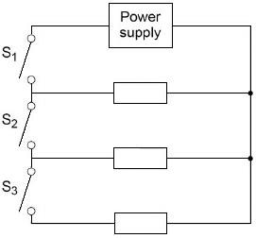
(a) Complete the sentence.
The three resistors in above diagram are connected in _______________ with the power supply.
(1)
(b) Which switch must always be closed for the hair dryer to work?
Tick (✓) one box.

S₁ | 
S₂
S₃
(1)
(c) Which switches must be closed for the hair dryer to work at maximum power output?
Tick (✓) one box.

S₁ and S₂
S₁ and S₃
S₁, S₂ and S₃
(1)
Use the Physics Equations Sheet to answer parts (d) and (e).
(d) Write down the equation which links energy transferred (E), power (P) and time (t).
___________________________________________________________________
(1)
(e) The heating elements have a maximum power output of 1200 W.
The energy transferred to the heating elements to reach normal operating temperature is 3600 J.
Calculate the time taken for the heating elements to reach normal operating temperature at maximum power output.
___________________________________________________________________
___________________________________________________________________
___________________________________________________________________
___________________________________________________________________
___________________________________________________________________
___________________________________________________________________
Time = __________s
(3)
(f) The hair dryer has LEDs to indicate the power setting.
What is the circuit symbol for an LED?
Tick (✓) one box.

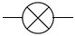
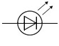
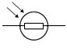
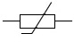
(1)
(Total 8 marks)
Q2.
A student investigated how the current in a circuit varied with the number of lamps connected in parallel in the circuit.
Figure 1 shows the circuit with three identical lamps connected in parallel.
Figure 1
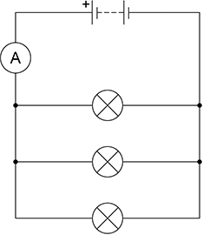
Figure 2 shows the results.
Figure 2
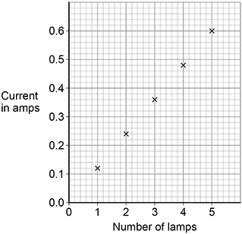
(a) Complete the sentences.
Choose answers from the box.
Each answer can be used once, more than once or not at all.

decreased | stayed the same | increased
As the number of lamps increased, the current __________________.
As the number of lamps increased, the total resistance of the circuit
_____________________ .
As the number of lamps increased, the potential difference across the battery
_____________________ .
(3)
(b) When there were three lamps in the circuit the ammeter reading kept changing between 0.35 A and 0.36 A.
What type of error would this lead to?
Tick (✓) one box.

Random error
Systematic error
Zero error
(1)
Figure 3 shows a circuit with five ammeters and three identical lamps.
Figure 3
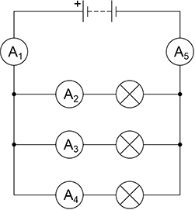
(c) Complete the table below to show the readings on ammeters A₂ and A₅.

Ammeter | A₁ | A₂ | A₃ | A₄ | A₅
Current in amps | 0.36 |  | 0.12 | 0.12
(2)
(d) The resistance of one lamp is 15 Ω.
The current in the lamp is 0.12 A.
Calculate the power output of the lamp.
Use the equation:
power = (current)² × resistance
___________________________________________________________________
___________________________________________________________________
___________________________________________________________________
Power = _______________ W
(2)
(Total 8 marks)
Q3.
A student investigated how the total resistance of identical resistors connected in series varied with the number of resistors.
The student used an ohmmeter to measure the total resistance of the resistors.
The diagram below shows the student’s circuit with 3 resistors.
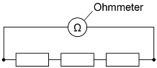
The student repeated each reading of resistance three times.
The table below shows the student’s results for 3 resistors in series.

Number of resistors | Total resistance in Ω
Number of resistors | Reading 1 | Reading 2 | Reading 3 | Mean
3 | 35.9 | 36.0 | 36.1 | 36.0
(a) Calculate the mean resistance of 1 resistor.
___________________________________________________________________
___________________________________________________________________
___________________________________________________________________
Resistance = _______________ Ω
(2)
(b) What was the resolution of the ohmmeter the student used?
Tick (✓) one box.

0.1 Ω |  | 0.2 Ω |  | 1.1 Ω |  | 36.0 Ω
(1)
(c) How do the results show that the student’s measurements were precise?
Tick (✓) one box.

The measurements are accurate.
The measurements are grouped closely together.
The measurements are reproducible.
(1)
The graph below shows the results.
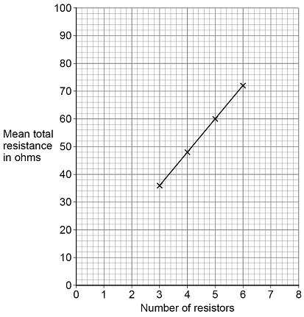
(d) How do the results show that the total resistance is directly proportional to the number of resistors?
Tick (✓) one box.

The results give a line with a positive gradient.
The results give a straight line that would go through the origin.
The results show a linear relationship.
(1)
(e) Predict the mean total resistance of 7 resistors.
Use the graph above.
Mean total resistance of 7 resistors = _______________ Ω
(1)
(f) Some resistors are connected in series with a battery.
When more resistors are added in series, the total resistance increases.
Complete the sentences.
Choose answers from the box.
Each answer may be used once, more than once or not at all.

decreases | increases | remains the same
When the number of resistors increases, the potential difference across each
resistor _______________.
When the number of resistors increases, the current in the circuit
______________________________.
(2)
(Total 8 marks)
Q4.
Figure 1 shows a circuit diagram.
Figure 1
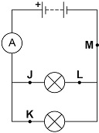
(a) In which position could a switch be placed so that both lamps can be switched on or off at the same time?
Tick (✓) one box.

J |  | K |  | L |  | M
(1)
(b) Draw the circuit symbol for a switch in the box below.

(1)
(c) In 30 seconds, 24 coulombs of charge flow through the battery.
Calculate the current in the battery.
Use the equation:
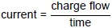
___________________________________________________________________
___________________________________________________________________
___________________________________________________________________
___________________________________________________________________
Current = ___________________________ A
(2)
(d) There is a potential difference of 3.6 V across the battery.
Calculate the energy transferred by the battery when 60 coulombs of charge flows through the battery.
Use the equation:
energy transferred = charge flow × potential difference
___________________________________________________________________
___________________________________________________________________
___________________________________________________________________
___________________________________________________________________
Energy transferred = ___________________________ J
(2)
A student built Circuit X and Circuit Y shown in Figure 2.
The components used in each circuit were identical.
Figure 2
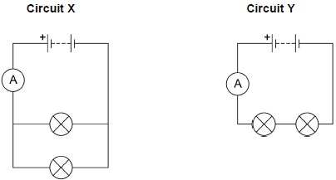
(e) How would the reading on the ammeter in Circuit Y compare to the reading on the ammeter in Circuit X?
Tick (✓) one box.

The reading in Y would be higher.
The reading in Y would be lower.
The readings would be the same.
(1)
(f) How does the total resistance of Circuit Y compare with the total resistance of Circuit X?
Tick (✓) one box.

The total resistance of Y is greater.
The total resistance of Y is less.
The total resistance is the same.
(1)
The student built another circuit which is shown in Figure 3.
Figure 3
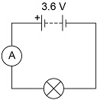
(g) Write down the equation which links current, potential difference and resistance.
___________________________________________________________________
(1)
(h) There is a potential difference of 3.6 V across the lamp in Figure 3.
The current through the lamp is 0.80 A
Calculate the resistance of the lamp.
___________________________________________________________________
___________________________________________________________________
___________________________________________________________________
Resistance = ___________________________ Ω
(3)
(Total 12 marks)
Q5.
(a) Figure 1 shows the inside of a battery pack designed to hold three identical 1.5 V cells.
Figure 1
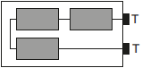
Which one of the arrangements shown in Figure 2 would give a 4.5 V output across the battery pack terminals T?
Figure 2
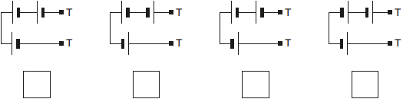
(1)
(b) Figure 3 shows a variable resistor and a fixed value resistor connected in series in a circuit.
Figure 3
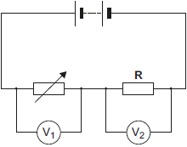
Complete Figure 3 to show how an ammeter would be connected to measure the current through the circuit.
Use the correct circuit symbol for an ammeter.
(1)
(c) The variable resistor can be adjusted to have any value from 200 ohms to 600 ohms.
Figure 4 shows how the reading on voltmeter V₁ and the reading on voltmeter V₂ change as the resistance of the variable resistor changes.
Figure 4
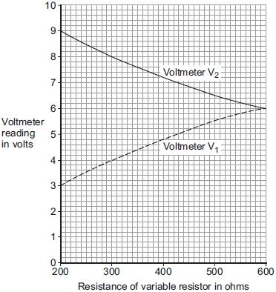
(i) How could the potential difference of the battery be calculated from Figure 4?
Tick (✔) one box.

9 + 3 = 12 V | 
9 – 3 = 6 V
9 ÷ 3 = 3 V
Give the reason for your answer.
______________________________________________________________
______________________________________________________________
(2)
(ii) Use Figure 4 to determine the resistance of the fixed resistor, R.
Resistance of R = ___________ Ω
Give the reason for your answer.
______________________________________________________________
______________________________________________________________
(2)
(iii) Calculate the current through the circuit when the resistance of the variable resistor equals 200 Ω.
______________________________________________________________
______________________________________________________________
______________________________________________________________
Current = ___________ A
(3)
(Total 9 marks)
Q6.
A student set up the electrical circuit shown in the figure below.
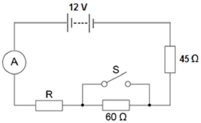
(a) The ammeter displays a reading of 0.10 A.
Calculate the potential difference across the 45 Ω resistor.
___________________________________________________________________
___________________________________________________________________
Potential difference = _______________________ V
(2)
(b) Calculate the resistance of the resistor labelled R.
___________________________________________________________________
___________________________________________________________________
___________________________________________________________________
Resistance = _______________________ Ω
(3)
(c) State what happens to the total resistance of the circuit and the current through the circuit when switch S is closed.
___________________________________________________________________
___________________________________________________________________
___________________________________________________________________
___________________________________________________________________
(2)
(Total 7 marks)
Q7.
The current in a circuit depends on the potential difference provided by the cells and the total resistance of the circuit.
(a) Figure 1 shows the graph of current against potential difference for a component.
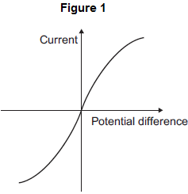
What is the name of the component?
Draw a ring around the correct answer.

diode | filament bulb | thermistor
(1)
(b) Figure 2 shows a circuit containing a 6 V battery.
Two resistors, X and Y, are connected in parallel.
The current in some parts of the circuit is shown.
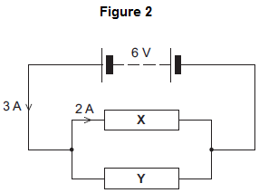
(i) What is the potential difference across X?
Potential difference across X = _______________ V
(1)
(ii) Calculate the resistance of X.
______________________________________________________________
______________________________________________________________
Resistance of X = _______________ Ω
(2)
(iii) What is the current in Y?
Current in Y = _______________ A
(1)
(iv) Calculate the resistance of Y.
______________________________________________________________
Resistance of Y = _______________ Ω
(1)
(v) When the temperature of resistor X increases, its resistance increases.
What would happen to the:
• potential difference across X
• current in X
• total current in the circuit?
Tick () three boxes.

 | Decrease | Stay the same | Increase
Potential difference
across X
Current in X
Total current in the circuit
(3)
(Total 9 marks)
Q8.
Figure 1 shows some hair straighteners.
Hair straighteners contain heating elements.
Figure 1

(a) When the hair straighteners reach normal operating temperature, an LED turns on.
Draw the circuit symbol for an LED in the box.

(1)
Figure 2 shows the circuit diagram for the hair straighteners.
Each resistor represents a heating element.
The power output of the hair straighteners can be changed by closing different switches.
Figure 2
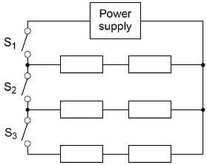
(b) Why do the hair straighteners not turn on when only switch S₂ is closed?
___________________________________________________________________
___________________________________________________________________
(1)
(c) The hair straighteners have a maximum power output of 120 W.
The energy transferred to the hair straighteners to reach normal operating temperature is 3.6 kJ.
Calculate the time taken for the hair straighteners to reach normal operating temperature when operating at maximum power.
Use the Physics Equations Sheet.
___________________________________________________________________
___________________________________________________________________
___________________________________________________________________
___________________________________________________________________
___________________________________________________________________
___________________________________________________________________
Time = _______________ seconds
(4)
(d) Figure 3 shows the hair straighteners circuit with switch S₁ closed.
Figure 3
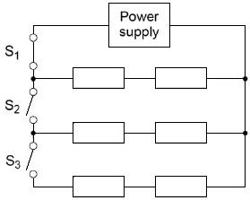
Switch S₂ and switch S₃ are then closed at the same time.
Explain what happens to the power output of the power supply.
___________________________________________________________________
___________________________________________________________________
___________________________________________________________________
___________________________________________________________________
___________________________________________________________________
___________________________________________________________________
___________________________________________________________________
___________________________________________________________________
(3)
(Total 9 marks)

Mark schemes
Q1.
(a) parallel
1
(b) S₁
1
(c) S₁, S₂ and S₃
1
(d) energy transferred = power × time
or
E = P × t
1
(e) 3600 = 1200 × t
1
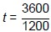
1
t = 3 (s)
1
(f)
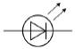
1
[8]
Q2.
(a) increased
1
decreased
1
stayed the same
1
(b) random error
1
(c) A₂ = 0.12 (A)
1
A₅ = 0.36 (A)
1
(d) P = 0.12² × 15
1
P = 0.216 (W)
1
[8]
Q3.
(a) R=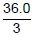
1
R = 12.0 (Ω)
1
(b) 0.1 Ω
1
(c) The measurements are grouped closely together
1
(d) The results give a straight line that would go through the origin.
1
(e) 84 (Ω)
allow an answer between 83 and 85 (Ω) inclusive
1
(f) decreases
1
decreases
1
[8]
Q4.
(a) M
1
(b)
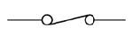
or
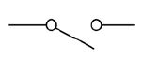
1
(c)
an answer of 0.8 (A) scores 2 marks
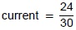
1
current = 0.80 (A)
1
(d)
an answer of 216 (J) scores 2 marks
E = 60 × 3.6
1
E = 216 (J)
1
(e) The reading in Y would be lower
1
(f) The total resistance of Y is greater
1
(g) potential difference = current × resistance
or
V = IR
1
(h)
an answer of 4.5 (Ω) scores 3 marks
3.6 = 0.80 × R
1
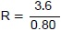
1
R = 4.5 (Ω)
1
[12]
Q5.
(a) 3rd box from the left ticked
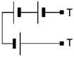
1
(b) correct symbol drawn in series with other components
symbol must have upper case A
1
(c) (i) 9 + 3 = 12V
reason only scores if this mark scored
1
pd of battery is shared between the variable resistor and fixed resistor
accept V₁ + V₂ = pd of the battery
accept p.d. is shared in a series circuit
accept voltage for p.d.
1
(ii) 600
reason only scores if this mark scored
1
p.d. of supply shared equally when resistors have the same value
or
ratio of the p.d. is the same as the ratio of the resistance
1
(iii) 0.015
or
their (c)(i) ÷ (their (c)(ii) + 200) correctly calculated
allow 2 marks for correct substitution ie 12 = I × 800
or
their (c)(i) = I × (their (c)(ii) + 200)
allow 1 mark for total resistance = 800 (Ω) or their (c)(ii) + 200
or
allow 1 mark for a substitution of 12 = I × 200
or
their (c)(i) = I × 200
or
alternative method using the graph
V = 3 V (1)
3 = I × 200 (1)
3
[9]
Q6.
(a) V = 0.10 × 45
1
4.5 (V)
1
(b) R = 12 / 0.10
1
total resistance = 120 (Ω)
1
R = 120 – 105 = 15 (Ω)
1
(c) (total) resistance decreases
1
(so) current increases
1
[7]
Q7.
(a) filament bulb
1
(b) (i) 6 V
1
(ii) 3 Ω or their correctly calculated
allow 1 mark for correct substitution ie
6 = 2 × R
or their (i) = 2 × R
2
(iii) 1 A
1
(iv) 6 Ω or their (i) / their (iii) correctly calculated
1
(v)
Decrease | Stay the same | Increase
1
1
1
[9]
Q8.
(a)
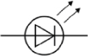
allow:
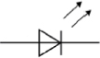
1
(b) there is a gap in the circuit
or
S₁ needs to be closed to complete the circuit
or
S₁ needs to be closed to turn the hair straighteners on
1
(c) E = 3600 (J)
1
3600 = 120 × t
this mark may score if E is incorrectly / not converted
1
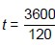
this mark may score if E is incorrectly / not converted
1
t = 30 (s)
allow an answer consistent with their value of E
1
(d) the total resistance of the circuit decreases
1
so the current increases
1
which increases the power output
1
[9]

